Adam Clarke – Campus ID 996283360

Arizona State University

IEE 593 – Engineering Management Applied Project

December 2, 2022

Offline Telemetry Monitoring Tool Project Summary

Offline Telemetry Monitoring Tool (OTMT) Project Summary

# ABSTRACT

**SPC charts would allow for the statistical monitoring of data that is already being gathered but not consistently being used with the DISH SOC. In order to use control charts, the data needs to be pre-processed in order to remove the periodic effects of a spacecraft’s orbit. While the final implementation of the control chart software tool only works with single points of data, future updates would allow for multivariate monitoring and regression analysis to be performed directly within the software. Care needs to be taken when using the control charts to ensure that the data being tracked falls somewhat closely to a normal distribution, but some methods are discussed that help address that issue.**

Contents

ABSTRACT 1

INTRODUCTION 2

LITERATURE REVIEW 4

Addressing Non-Normality 4

SPC and Spacecraft Operations 6

Multivariate Analysis 7

PROJECT PLAN 7

PROJECT EXECUTION 12

Overview 12

Trend 1 – Thruster Pointing Behavior 13

Trend 2 – Payload Input Power 15

Trend 3 – Array Current 17

Trend 4 – Motor Current 18

FUTURE IMPROVEMENTS 21

Initial Project Scope 22

p/np chart 23

Multivariate Analysis 23

Machine Learning and Data Regression 24

Spacecraft Data Distribution 24

References 26

Appendix A – Initial Gantt Chart 27

Appendix B – Enumerated Requirements 28

Appendix C – Final Project Schedule (Gantt Chart) 29

Appendix D – Trend Phase I Data Distribution Plots 30

# INTRODUCTION

In spacecraft operations there is a large amount of data gathered for individual spacecrafts. Data can vary drastically across the satellite. It includes (but is not limited to) Boolean states giving the on/off status for a heater on the satellite, counts of the number of a certain type of event that has occurred on-orbit, or a digitized values of the electrical current being drawn by an individual piece of hardware. As the data arrives on the ground it is processed by a ground system that checks the value of each telemetry point against a set of pre-defined limits. These limits are set using a mix of the spacecraft manufacturer’s definition of what constitutes anomalous values and engineering intuition based on manual analysis of past performance. If the raw value of telemetry violates any of these limits an audio and visual alarm is kicked off for the operator to investigate further.

All the data is then stored in a ground database for future trending and analysis needs. Spacecraft Engineers use this data to perform trends on a recurring basis, ranging from a daily to yearly frequency. These trends are meant to identify anomalies before they occur or grow out of control. Some of the trends are automated, but most of them are done manually and have room for misinterpretation or human error. Data not nominally included in these recurring trends is usually never looked at further, and data used for the recurring trending is generally only used the one time. There is a lot of data being gathered and stored that is not used and is potentially being wasted.

An offline telemetry monitoring system would help utilize this extra data while bridging the gap between live telemetry checking and offline trending. Engineers can identify key pieces of telemetry that can then be tracked using robust control charts that are set based on actual performance instead of best-guess predictions. Control charts have a rich history of use in manufacturing processes and validation, but there is no consistent statistical analysis that is done within the DISH SOC.

This paper is split into four sections. First a literature review will be presented that discusses pieces of literature that relate to the implementation of the OTMT. Literature addressing control charts and their use on high volume and highly non-normal data was sought out to determine if any specific cautions needed to be taken when developing the project tool. Then there is a section dedicated to the planning and pre-development work that went into developing OTMT. This includes a summary of the initial project schedule and meeting sessions that resulted in the final project requirements. The third section discusses the execution of the project plan and summarizes some of the initial charts that were built using OTMT. Finally, problems discovered during the implementation of OTMT as well as future improvements that can be made to the first version of the software will be reviewed.

# LITERATURE REVIEW

Many different pieces of literature were referenced in preparation for and to address issues that arose during this project. A generalized literature review follows, but a more detailed annotated bibliography was created in preparation for the literature review and is available upon request.

There were a few specific areas of concern that needed to be investigated more before getting too far into the project. Specifically, there is an overabundance of data for any specific system that would be monitored with OTMT. Data comes down as often as once every half second. If all the data is used and each reading is counted as a sample size, the calculated control limits would be too tight for operational use.

This is exacerbated by the second problem: it is very likely that the data to be monitored is not normally distributed nor independent. On any given spacecraft there are many different subsystems that all affect the behavior of the others. Additionally, measurements can change due to the current location of the spacecraft in orbit. All the spacecraft being tracked with this tool will be in a Geostationary orbit; they complete a single orbit once every 24 hours. This means that data can vary over 24-hour cycles. There is also a seasonal component to most of the data, meaning that the data can vary over an entire year. Ultimately this means that the data will most likely not fall into a normal data distribution and is not independent (i.i.d).

## Addressing Non-Normality

Huberts et al. [4] suggests that the normality and i.i.d assumption can be ignored if the process being sampled has enough data being gathered. They show that given a large enough set of data that most distributions, when averaged and tracked as subgroups, fall closely to the performance of a normally distributed dataset. Veramaat et al. [10] come to a similar conclusion. They find that for large sample sizes, existing non-parametric control charts work well enough for most data distributions, and control charts based on the normality assumption still work, just with a much higher rate of false positives.

There is also literature out there that discusses other ways of dealing with non-normal data besides utilizing large data samples. Croux et al. [2] implement the Holt-Winters forecast method for time series data and compare the value of their one step ahead forecast to the actual value once it comes in. This method alleviates some of the autocorrelation that may exist within a time series data set. For data with outliers, in the training or the test set, the authors suggest a more robust version of the Holt-Winters method. Tracking the error value then allows the use of conventional control charts, as the error should be normally distributed. Qui and Zhang [8] attempted to use parametric transformations to increase the effectiveness of monitoring non-normal datasets using control charts based on the normality assumption. They found that overall, there was not much to be gained from transforming the data before monitoring compared to simply using existing control charts that account for the non-parametricity of the initial data.

Rakitzis, Weiß, and Castagliola [9] explore control charts that can be used for correlated Poisson distribution data with excess zeros. There are existing control charts for autocorrelated Poisson data; however, an excessive number of zeros causes the usability of these charts to drop. Based on the ARL performance of control charts created using zero-inflated Poisson models, the authors conclude that making adjustments to the UCL for a Shewhart chart and the h/k parameters for a CUSUM charts result in reliable control charts for zero inflated count data. Ottensteuer [7] also investigated control charts for count data. They suggest implementing a Shiryaev-Roberts (SR) control chart in lieu of a CUSUM control chart for Markovian Count time series data. Sets of SR charts were compared to their corresponding CUSUM charts using ARL. For a majority of the cases SR charts outperformed CUSUM charts. While most data that needs to be tracked on a spacecraft is not directly count related (Poisson or otherwise), there may arise a need in the future to be able to track such data.

## SPC and Spacecraft Operations

Other authors address the application of conventional control charts and statistical process control (SPC) within spacecraft operations directly. Al-Zaidy et al. [1] note the same difficulty as this author in having to deal with highly correlated data. They used a mixture of machine learning and multivariate control charts to monitor different functions on their spacecraft. Machine learning allowed them to gather their spacecraft data into different groups for labelling. Using PCA and Hotelling’s T2 statistic allowed them to transform the correlated data and track the new principal components for a change in process performance or variance. Nalepa et al. [5] also use machine learning; they create time series regressions for points of interest on the satellite. The error between the values predicted by the machine learning algorithm and the actual value reported by the spacecraft is calculated and tracked. They do not use conventional control charts for the error data (they are building models to include directly on the spacecraft software to automate anomaly response), but their methods for calculating error and model metrics lend themselves nicely to tracking spacecraft data in general. The metrics they suggest allow the user to determine not only how close a model is to actual telemetry performance, but also how much lead or lag time there is to an anomaly. Being able to predict if a process is about to go out of control can save a lot of time in spacecraft operations.

Hodder [3] implements SPC (specifically IR charts) to track how well their ground system is performing on a monthly basis in terms of availability. Before using any statistical processes, any changes in the overall availability were left up to subjective interpretation and led to investigations that didn’t have any overall goal of finding common causes or resolutions. After implementing SPC the data was able to be presented in a much more formal manner. While the initial implementation of OTMT is meant for spacecraft telemetry, other ground system metrics would be able to be imported for easy visualization if desired.

## Multivariate Analysis

Finally, a couple authors discuss the monitoring of multiple variables at once. There is a large variety of data that is reported by the spacecraft and having to track each piece of data individually is unrealistic. Instead, a multivariate approach to control charts could be taken. Nidsunkid et al. [6] investigate the effect of the violation of the normality assumption for multivariate (MV) Shewhart and MEWMA control charts. They show that when using a MV Shewhart chart any violation in the normality assumption greatly affects the ARL. Using an MV EWMA chart reigns in the effect that normality violations have on the ARL of a process. Both types of charts suffer if the non-normal distribution has skewed tails. As mentioned earlier, Al-aidy et al. [1] used PCA to reduce the number of variables down to a manageable size. In their example they reduced a set of 40 variables with a PCA model that resulted in only two components needing to be tracked.

# PROJECT PLAN

The planning of this project began with a scope statement. The scope statement contained much of what was discussed in the introduction section of this paper, but also included an acceptance criteria list that acted as an early version of the final tool’s requirements and the final deliverables that would be available once the final version of the OTMT software was released. These evolved into a presentation that was given to the management team in the DISH SOC in order to get initial approval for the project. This presentation was given in early 2022, nearly 6 months before the start of the Fall 2022 semester. Approval for new tools and projects moves pretty slowly in the SOC, and there were already a few large team-wide projects slated for 2022. It was critical that the project be approved early so that some planning could be done before the team got too busy to help.

Shortly after the initial project presentation was given to SOC management in February 2022 there was an event that required the focus of the entire SOC. Eventually in April of 2022 things slowed down and the project was finally approved, and key stakeholders were assigned. A kickoff meeting was scheduled at the end of April 2022 after which the official project plan and schedule could be refined.

The first month of the project was dedicated to working with various SOC team members to develop a set of requirements and basic design for the OTMT. The kickoff meeting was used to explain the concept of control charts and how they might be applied to spacecraft data, after which the group brainstormed ways to implement the process by either using existing SOC tools or developing new ones. It was decided that new software would be written in the SOC sandbox environment. This would allow for more flexibility when developing the tool while also utilizing a newly implemented function within the sandbox that allowed for direct database queries from Python.

In addition to the initial group feedback, a brief brainstorming session was held with the leaders of the subsystem teams. The subsystem leads act as subject matter experts for their specific subsystems (Attitude Control, Thermal, Propulsion, etc.). After explaining the project to them, they were asked to come up with various key pieces of telemetry that they thought were not tracked efficiently with the limits that were implemented on live telemetry. Additionally, they were asked if there were any points that had shown anomalous behavior in the past that was only seen long after the initial indications had occurred. The examples given by the team were gathered and used as test cases as the tool was developed.

The initial design for the project had the software split into three different parts that would undergo development one at a time: Control Chart (CC) Prediction, CC Update, and CC Monitor. Each piece of software would feed into the next; the user would use CC Prediction to create a control chart definition, then use CC Update to add new data to their chart database, and finally use CC Monitor to plot and check their data for Out of Control (OOC) points. The plan was to develop the software in the same order. An initial Work Breakdown Structure (WBS) was created to reflect the plan. The Gannt Chart is available as an image in Appendix A – Initial Gantt Chart but is available as a Microsoft project file upon request. A high-level flowchart of the system design is shown in Figure 1. While the schedule had an end date that occurred in August 2022, that was based on the assumption that 40 hours per week would be put into OTMT. Realistically up to 20 hours per week would be able to be allocated to the project, meaning the initial schedule would span from May 2022 to the end of October 2022. That would leave enough time at the end of the project to gather data and write a final report on the project itself.

Figure 1. Initial OTMT System Flowchart

After beginning development of the prediction software, it quickly became apparent that all three parts would need to be developed at the same time. In order to ensure the prediction software was working properly the data needed to be updated and plotted to check whether or not the control chart definition and data storage files contained the proper information and were being formatted properly. Feedback during the first gate review with the key stakeholders yielded similar feedback. They were concerned that focusing all of the development in a ‘waterfall’ approach would hold up progress of the tool and result in a longer amount of time before a minimally viable product was available.

Figure 2. Final OTMT System Flowchart

The initial requirements were sorted into three groups (versions): required for a basic functioning product (v0.3), high priority usability requirements (v0.6), and lower priority quality of life requirements (v0.9). These groups of requirements would be used to deliver iterative versions of OTMT while holding at each version for a gate review of the progress so far. In this way the project fell into an Agile-type schedule, where a set of features were added to the software and then reviewed by the key stakeholders before moving forward with the next batch of features. The list of requirements labeled with their corresponding versions are given in Appendix B – Enumerated Requirements. A corresponding project schedule built in Microsoft Project is given in Appendix C – Final Project Schedule (Gantt Chart). The final OTMT System Flowchart is shown in Figure 2 and a PERT chart detailing the critical path is shown in Figure 3. The final flowchart is similar to the original flowchart in that it still has the three different portions of software (Prediction, Update, and Monitor), but it more accurately reflects how data flows between all three portions and how everything interfaces with a central repository. The PERT diagram shows the critical path and which tasks would impact the schedule the most.

Figure 3. OTMT PERT/CPM Diagram

Development continued on-schedule for the rest of the project. The gate reviews had the biggest impact on the official schedule. This is backed up by the PERT diagram; each of the gate reviews occur early on the critical path. Even though features could be added quickly, each new version needed to be approved before dedicating time to the next version. Additionally, the final gate review had to be rescheduled due to availability issues related to unrelated activities occurring on the DISH SOC fleet. Eventually, everything was approved and given the go ahead for user testing and feedback, which is where the project currently stands. Once users have the chance to test out the software with their own data, find any bugs, and think of new use cases, a final version of the software will be written, tested, and published per the project schedule.

# PROJECT EXECUTION

## Overview

OTMT supports four different types of classic SPC charts: Shewhart, Exponentially Weighted Moving Average (EWMA), Cumulative Sum (CUSUM), and proportion/number non-conforming (p/np). It also includes a fifth type of chart that allows the user to immediately define their own upper and lower control limits. This is because some telemetry has known good/bad values, so allowing the user to define their own limits based on these values gives addition uses for the tool.

The Shewhart chart is implemented as an individuals ($\overline{X}|MovingRange$) chart. In the literature review, as mentioned in the literature review, there is too much data gathered and too much variance in the spacecraft telemetry to use every sample returned in telemetry. Even the lowest rate telemetry results in nearly 2700 samples per day. Instead, the user supplies a time range for which to average their telemetry over (nominally daily or weekly) and then that average value is inserted as an individual sample. The same averaging scheme is implemented for the other types of charts as well. This helps address multiple issues caused by the fact that a majority of the spacecraft telemetry varies throughout the day. Utilizing a daily average not only removes the daily component of variance, allowing for tighter control limits, but it also helps take the original non-parametric data and condenses it to a set of data that more closely resembles a normal distribution, allowing easier implementation of SPC control charts.

The control charts are then tracking things on a daily or weekly (or longer) basis. The frequency of the chart updates depends on how important it is to catch an OOC process on the spacecraft and how tolerant the user is to false positives and non-normality in their data. Weekly data helps remove outliers and temporary (but expected) shifts in the data being tracked, but any shifts in the process being tracked will take at least seven days to catch. Alternatively, daily data will allow for the earlier detection of an OOC process but is also more susceptible to false positive alerts, whether it be due to nominal activities planned on the spacecraft or random noise.

Five different trends were prepared for discussion in this paper. Different types of data based on known anomalies or process shifts were gathered from the spacecraft in the DISH SOC fleet added to control charts for tracking. They utilize either Shewhart charts or CUSUM charts. EWMA charts fill a similar role to the CUSUM charts in being able to catch smaller shifts in data, and with the way the data was standardized a Shewhart chart more intuitively shows how the data is changing from sample to sample. The p/np charts were implemented in the software, but any existing (identified) count processes better fit the Shewhart chart. Therefore, no p/np charts were included as examples, but they are ready to be used if an engineer identifies a consistent count process.

The data presented below has been standardized and offset to a starting date of 01/01/1970, which is the start date of the Unix epoch, to avoid any concerns with the transfer of proprietary or confidential information. It is for the same reason that the data is labeled and discussed in a vague manner. The intent for the various trends shown below is to demonstrate that the software as it is currently implemented is able to catch, and in some cases predict, anomalous conditions on the spacecraft being flown by the DISH SOC.

## Trend 1 – Thruster Pointing Behavior

Some thrusters have the capability to offset their pointing to minimize the amount of torque applied to the spacecraft. This is helpful when wanting to apply an orbit-changing amount of force to the spacecraft without disturbing its pointing. A large shift in this offset requires additional commanding on the spacecraft and is checked for on a quarterly basis. A daily average of this offset was taken and added to a Shewhart control chart. Figure 4 shows the Shewhart chart over (a) the entire duration of the trend and (b) the final 50 days of the trend.

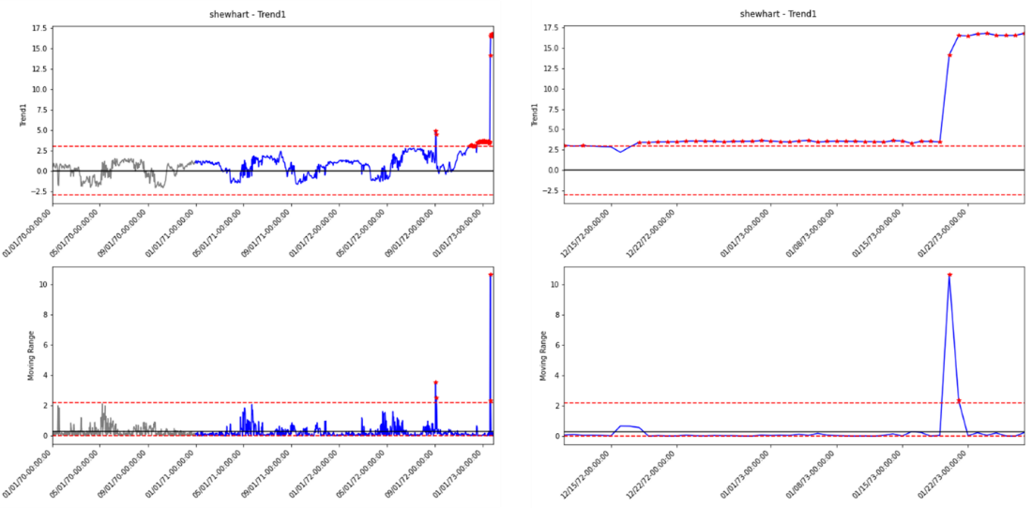The chart was initialized with a year of IC daily averages (365 samples total). The limits were set to $3σ$ for the individuals chart. The moving range limits were manually set to just past the maximum seen based in the IC MR data. A deviation in behavior is seen starting early 1972 (based on the plot range). A brief violation of the control limits is seen around 09/01/1972, but subsequently returns to IC values. Consistent OOC behavior begins in December 1972, with a much larger jump in value caught by the MR chart in early 1973.

Figure 4. Shewhart Chart for Thruster Pointing Data. (a) Left, long-term duration. (b) Right, last 50 days. Grey indicates Phase I data, Blue indicates Phase II data, Red markers indicate OOC points

The large jump is due to a known change in the “process”, in this case the process being the thruster pointing. The thruster was swapped to a spare unit based on abnormal performance of the original unit. In fact, this data was chosen specifically because the shift was seen in quarterly trending and was identified as a test candidate for the OTMT software. The OOC behavior seen in December 1972, however, was unexpected. This thruster was already being watched due to previous issues, but recurring ground trending did not show any significant changes to its performance during maneuvers. The control chart suggests that the spacecraft had to repoint the thruster more than normal to account for the non-nominal behavior of the thruster. This information will be helpful in future; both for other thrusters on this spacecraft and other spacecraft in the DISH fleet.

## Trend 2 – Payload Input Power

The most important part of each spacecraft in the DISH SOC fleet is the payload. A majority of the payload is used to transmit television channel signals down to customers. Without the payload, there is no way for the spacecraft to generate any revenue for DISH, so it is vital that any payload related anomalies that occur are caught and addressed as quickly as possible. Before transmitting a signal down to the customers, each spacecraft needs to receive an uplink signal from the ground with the content that needs to be retransmitted. The power of this uplink signal is tracked on the spacecraft as Input Power, and a shift in the Input Power can mean a change in signal quality for the customers. It has been historically difficult to track raw input power using limits on the live telemetry stream as there are a lot of things that can cause temporary changes in the signal that would result in an excess of false positive alarms on the operations floor.

The input power for one of the payload units on orbit was averaged for both a daily and weekly duration and added to a CUSUM chart for further analysis. Phase I was analyzed with two years’ worth of data. The weekly analysis is shown in Figure 5 and the daily analysis is shown in Figure 6.

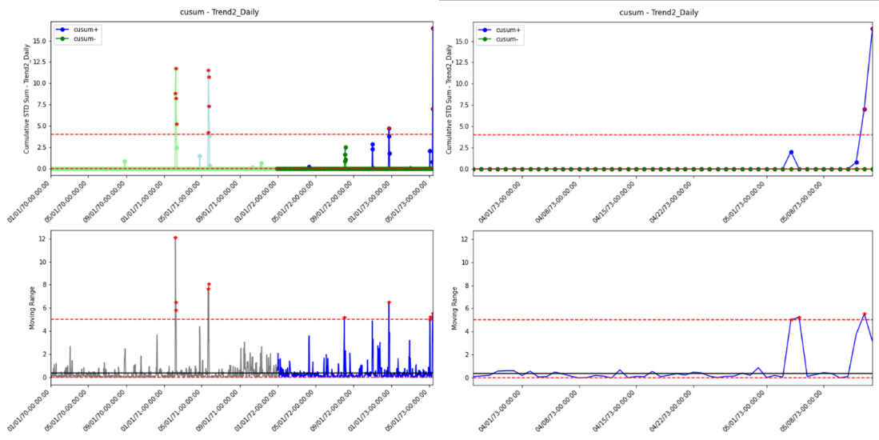

Figure 6. CUSUM Chart for Daily Input Power Data. (a) Left, long-term duration. (b) Right, last 50 days. Grey indicates Phase I data, Blue indicates Phase II data, Red markers indicate OOC points

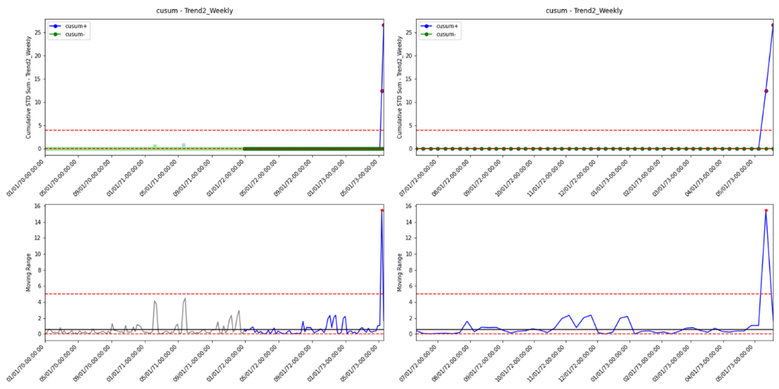

Figure 5. CUSUM Chart for Weekly Input Power Data. (a) Left, long-term duration. (b) Right, last 50 days. Light Blue/Green indicates Phase I data, Dark Blue/Green indicates Phase II data, Red markers indicate OOC points

There are two OOC events that occurred during the Daily Phase I analysis that were purposefully left in. They alarmed in both the CUSUM plot and the Moving Range plot and represent a temporary unexpected decrease in input power around January 1972 and a temporary unexpected increase in input power around May 1972. Both events are related to ground system maintenance. Further on in the daily data a handful of inconsequential OOC events are seen in the Moving Range plot and CUSUM plot, which are again filtered out by utilizing a weekly average. By utilizing weekly averages instead of daily averages, those events no longer cause an alarm on the control chart, demonstrating how choosing different analysis durations can impact the effectiveness of the user’s control chart. The tradeoff for the decrease in false positives seen in the weekly data is a slower response to OOC conditions but depending on the point being tracked this may not be an issue.

In May 1973, a large deviation in CUSUM+ occurs in both sets of data, with the initial alarm in the weekly data coming in approximately a week after the daily alarm. The shift and subsequent OOC behavior is due to an uncalibrated large-scale ground system change. Fortunately, this change was caught by the DISH operations team after weather had caused a different telemetry point to alarm in the live telemetry stream. An operator noticed a signature change when compiling additional plots which prompted further investigation. Without the random weather event, this shift in input power may have gone unnoticed for an extended period of time, whereas the CUSUM plots identify the issue almost immediately.

## Trend 3 – Array Current

Solar arrays are utilized to supply power to the spacecraft and charge the spacecraft batteries while the spacecraft is in the sun. Each solar array is made up of multiple components that are expected to degrade and potentially fail over time due to the volatility of space. While the spacecraft is designed to operate with multiple failures on the arrays, it is important to track the amount of power that each array can supply and identify failures as soon as possible. One way to do this on spacecraft with multiple arrays is to track the difference in power between each array. A shift in that value would indicate something happened on one of the arrays that should be investigated further.

Daily array power difference was gathered and implemented in a Shewhart chart. Phase I data consists of a year’s worth of data. The individuals chart limits were set to $3σ$ while the Moving Range chart limits were set based on historical performance.

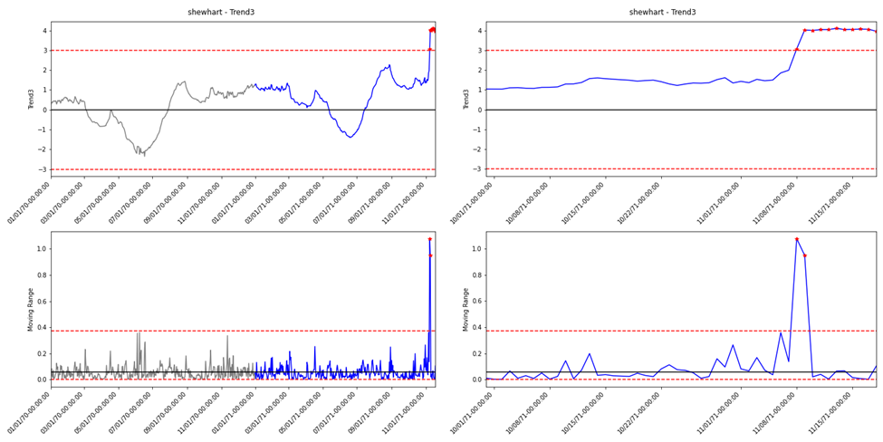A shift in November 1971 indicates an anomaly on one of the arrays. Occasionally these types of failures can recover, but most likely the shift in the mean difference value is permanent. If this chart had been actively being used during the anomaly it would need to be updated with new control limits to track the new mean.

Figure 7. Shewhart Chart for Daily Array Power Data. (a) Left, long-term duration. (b) Right, last 50 days. Grey indicates Phase I data, Blue indicates Phase II data, Red markers indicate OOC points

## Trend 4 – Motor Current

There are different types of hardware across the DISH SOC fleet. Most of the hardware has telemetry that can be monitored to determine the health of the unit. For this trend, the motor current for a type of unit that exists on multiple spacecraft has been gathered for two different spacecraft to show how a common trend can identify different things on different spacecraft.

First, a weekly average was taken on Spacecraft #1’s motor current. The resulting Shewhart chart can be seen in Figure 8. Phase I consists of a year of IC data. There are a couple of OOC points seen in the Moving Range plot, one during Phase I that was ignored and three during the Phase II monitoring that correspond to large but seemingly innocent shifts in motor current. At the end of the trend range a deviation in the motor current is captured as OOC alarms in the individual’s plot.

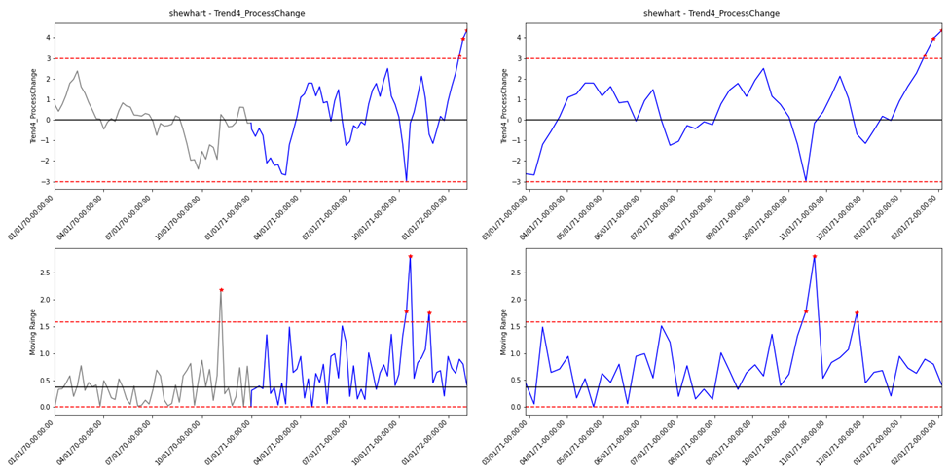This OOC signature was not initially expected when building this chart, but after reviewing spacecraft activities around the time of the deviation the signature is not concerning. A separate subsystem had recently undergone a planned change in how it was being operated. The new behavior reflected the spacecraft reacting to that change. The motor current was within operational limits, so to continue monitoring with OTMT a new set of control limits would need to be defined once an IC set of data could be built.

Figure 8. Shewhart Chart for Weekly Motor Current Data (Spacecraft #1). (a) Left, long-term duration. (b) Right, last 50 days. Grey indicates Phase I data, Blue indicates Phase II data, Red markers indicate OOC points

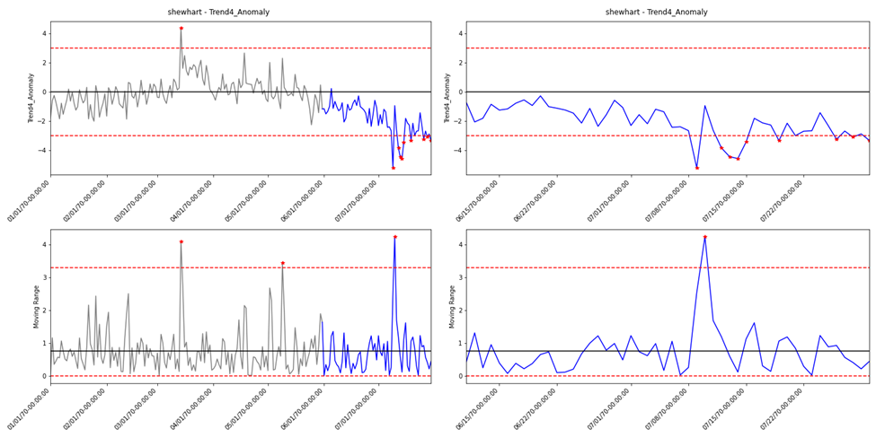The same motor current on a different spacecraft was gathered on a daily basis and added to a Shewhart chart. For this trend, there were only five months of IC data available for the Phase I analysis, therefore a daily average was used to allow for more Phase I samples versus the weekly average used for the other spacecraft. Figure 9 shows the resulting Individual’s and Moving Range plots. There is a slight OOC condition in the Phase I data due to other activities occurring on the spacecraft at that time, but the values were not extreme enough to warrant the creation of a new set of data.

Figure 9. Shewhart Chart for Daily Motor Current Data (Spacecraft #2). (a) Left, long-term duration. (b) Right, last 50 days. Grey indicates Phase I data, Blue indicates Phase II data, Red markers indicate OOC points

An initial OOC condition in the Phase II monitoring is reported on July 9th, 1970, followed by multiple sets of alarms shortly after indicating that something has happened to the unit being monitored. This anomaly was identified by live telemetry limits on July 15th, 1970, six days after the SPC chart identified an issue was occurring. Based on the Shewhart chart there appears to be a drift towards the anomalous behavior starting even earlier than July 9th.

The same data was implemented in a CUSUM chart to see how a different type of chart might help identify the same anomaly. The CUSUM chart is displayed in Figure 10.

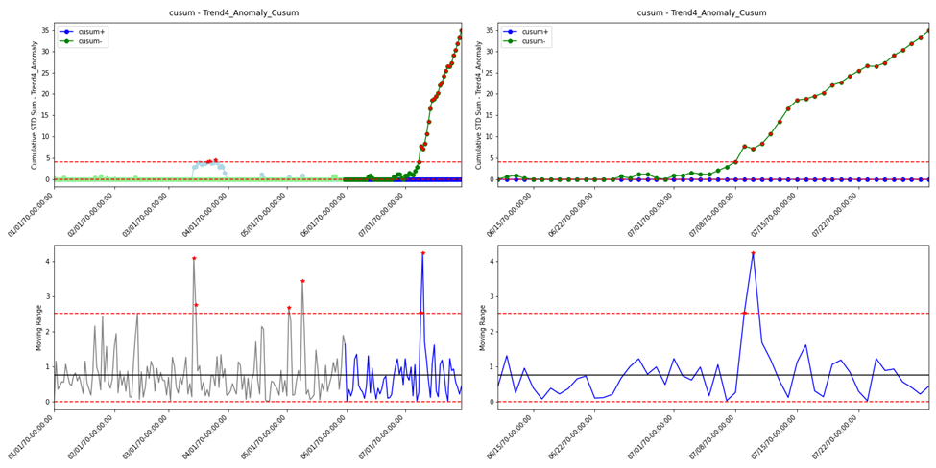This chart has an OOC condition first alarming on July 8th, 1970 but tracing the CUSUM- line back to where it first started to climb indicates that the anomaly truly began sometime in June 1970, nearly a month before the issue was identified in live telemetry. Implementing SPC to track this motor current would have not only allowed for an earlier identification of the anomaly, but also a more accurate estimate of when the unit began misbehaving.

Figure 10. CUSUM Chart for Daily Motor Current Data (Spacecraft #2). (a) Left, long-term duration. (b) Right, last 50 days. Light Blue/Green indicates Phase I data, Dark Blue/Green indicates Phase II data, Red markers indicate OOC points

# FUTURE IMPROVEMENTS

The entire project, from conception to planning to execution, was very successful. Even still there is always room for improvement, either by finding ways the planning and development could have gone better or by identifying future features and design changes that could be implemented to make the product even better. The following parts of this section detail the different improvements identified during the various project phases.

## Initial Project Scope

The initial scope of the project was much larger than what was eventually implemented. Originally the project plan included multiple teams within the SOC. The software team would be able to better utilize the existing database tools to not only make data queries go faster but also more efficiently store control chart data once it has been generated. The engineering team would be able to focus on providing use cases and feature requests based on initial versions of the software. A project manager would make sure that all people assigned to the project were able to give and receive the appropriate amount of feedback in a timely manner. By having more people assigned to the project, more features would be able to be added in the same amount of time it took to build the basic version presented in this paper. Additional features would have included built in multivariate analysis (discussed later), data regression, and automation.

Fortunately, the management teams responsible for approving the project understood that there was not enough personnel availability to meet the original scope. Features listed in the initial requirements were paired down to meet the capability of the assigned team members based on the amount of time they would be able to dedicate to the project and the software tools available to them. In the future, the SOC could consider larger projects that span across the different internal teams. As long as the project is managed properly, the team members would be able to work together and create a product that is useful to all teams and works efficiently within the SOC network.

## p/np chart

Part of the project requirements included implementing specific types of control charts. As discussed earlier, one of those control charts was a p/np chart to statistically track count data. After adding the chart type to the software and testing it with different types of data, it was realized that the control limits were too tight for the data that was being supplied and that instead of tracking “parts non-conforming” it would have been much easier and intuitive to track “defect count” type of telemetry, which would require a $c$ or $u$ chart instead. Having an additional person familiar with both control charts and spacecraft data may have prevented the extra time implementing a feature that would not be immediately useful.

## Multivariate Analysis

The software was designed to take in a single set of data and output a control chart analysis for engineering review. There are multiple spacecraft in the DISH SOC fleet, and on each spacecraft there are hundreds of points that would benefit from being monitored by an SPC chart. Inspecting the output of all points for all of the spacecraft would quickly become infeasible for even multiple engineers. Instead, as discussed in Nidsunkid et al. [6] and Al-aidy et al. [1], multiple points can be combined into a smaller number of variables to track using processes like PCA and Hotelling’s T-squared statistic.

These processes could either be implemented directly into the OTMT software in future updates or by preprocessing the data using a separate function to generate the final dataset that is pulled into OTMT. The first option would be beneficial for users of the software that are less familiar with multivariate analysis or do not have the software knowledge to implement their own form of data preprocessing. The second option is already available to be implemented by individual users but does require some amount of background in statistics to ensure the final variables being imported into OTMT are capable of detecting a shift in any of the original variables.

## Machine Learning and Data Regression

In the original scope of the project, there was a chance that machine learning and data regression could be implemented into OTMT. It was very quickly determined that there would not be enough time or personnel hours to get either feature implemented, but both are a very good candidate for future projects, either as additions to the existing software tool or as standalone tools that can be used to preprocess data being imported into the software tool.

Machine learning, similar to that performed by Al-Zaidy et al. [1], would allow engineers to sort the available spacecraft data into different groups to be monitored. Additional machine learning can be done afterwards to further classify the data within the groups and come up with prediction models that would allow engineers to compare new spacecraft data to the predicted values in order to determine an error variable that could then be tracked in OTMT. Non-machine learning data regression, like the one-step ahead prediction done by Croux et al. [2], would also be useful to perform a similar analysis.

## Spacecraft Data Distribution

One of the major assumptions when using the classic SPC charts discussed in this paper is that the data being tracked falls into the Normal distribution and is IID. The lit review covered different methods of accounting for non-normality and some of them were used. Specifically, the large amount of non-normal daily data was averaged together to form a single sample. Then, when possible, a large number of those daily samples were used to generate the Phase I data for a control chart, minimizing the effect of non-normality. Even with the averaged samples there is still non-normality that needs to be accounted for, whether it be passively acknowledged by the engineer performing the trend, actively accounted for by adjusting limits based on the skew/kurtosis of the data, or removed completely by pre-processing the data in a different manner (like tracking error values instead of actual values).

The distributions of each of the trends discussed in the section above are graphically shown in Appendix D – Trend Phase I Data Distribution Plots. For each trend, the Phase I data was gathered with a 1-minute average, a 1-day average, and a 1-week average. Then a histogram for each set of data was plotted alongside an overlay of the normal distribution. For the daily and weekly datasets, five more distributions are overlayed based on an analysis for best fit. Below the histograms, a probability plot shows the ordered data values (which were all standardized against themselves) vs. the theoretical normal quantiles. A normal data distribution would fall on a linear line which is included for most of the trends.

For all the trends, as the average duration increases, the final set of data approaches normality. This is extremely apparent in the Trend 4 data. Without any long-term averaging, the Phase I data spans well beyond $±3σ$ with extremely long tails. Once a daily average is applied, the impact of any planned operations or outliers within the initial set of data is greatly reduced. Being able to determine the data distribution of the Phase I data within the OTMT software itself would allow for better UCL and LCL calculations and could also act as a way to provide the user with a warning if the data is too non-normal for their chart to be statistically effective.

# References

1. Al-Zaidy, Ahmad M, Wessam M Hussein, Mahmoud M.A Sayed, and Ibrahim El-Sherif. 2018. "Data-Driven Models for Satellite State-of-Health Monitoring and Evaluation." *International Journal of Robotics and Mechatronics* 5 (1): 1-12.
2. Croux, Christophe, Sarah Gelper, and Koen Mahieu. 2011. "Robust Control Charts for Time Series Data." *Expert Systems with Applications* 13810-13815.
3. Hodder, James A. 2022. *The Use of Statistical Process Control in Deep Space Network Operations.* Research, Jet Propulsion Laboratory, California Institute of Technology, Pasadena: Jet Propulsion Laboratory.
4. Huberts, Leo C.E, Marit Schoonhoven, Rob Goesdhart, Mandala D Diko, and Ronals J.M.M Does. 2018. "The performance of X-bar control charts for large non-normally distributed datasets." *Quality and Reliability Engineering International* 979-996.
5. Nalepa, Jakub, Michal Myller, Jacek Andrzejewski, Pawel Benecki, Szymon Piechaczek, and Daniel Kostrzewa. 2022. "Evaluating Algorithms for Anomaly Detection in Satellite Telemetry Data." *Acta Astronautica* 689-701.
6. Nidsunkid, Sudarat, John J Borkowski, and Kamon Budsaba. 2017. "The Effects of Violations of the Multivariate Normality Assumption in Multivariate Shewhart and MEWMA Control Charts." *Quality and Reliability Engineering International* 2563-2576.
7. Ottenstreuer, Sebastian. 2022. "The Shiryaev-Roberts Control Chart for Markovian Count Time Series." *Quality and Reliability Engineering International* 1207-1225.
8. Qui, Peihua, and Jingnan Zhang. 2015. "On Phase II SPC in Cases When Normality is Invalid." *Quality and Reliability Engineering International* 27-35.
9. Rakitzis, Athanasios C, Christian H Weiß, and Philippe Castagliola. 2016. "Control Charts for Monitoring Correlated Poisson Counts with an Excessive Number of Zeros." *Quality and Reliability Engineering International* 413-430.
10. Vermaat, M.B. Thijs, Roxana A Ion, Ronald J. M. M Does, and Chris A. J Klaasen. 2003. "A Comparison of Shewhart Individuals Control Charts Based on Normal, Non-parametric, and Extreme-value Theory." *Quality and Reliability Engineering International* 337-353.

# Appendix A – Initial Gantt Chart

# Appendix B – Enumerated Requirements



# Appendix C – Final Project Schedule (Gantt Chart)

# Appendix D – Trend Phase I Data Distribution Plots

